**Unlock the Full Thrill: Get Geometry Dash 2.206 APK with Everything Unlocked**

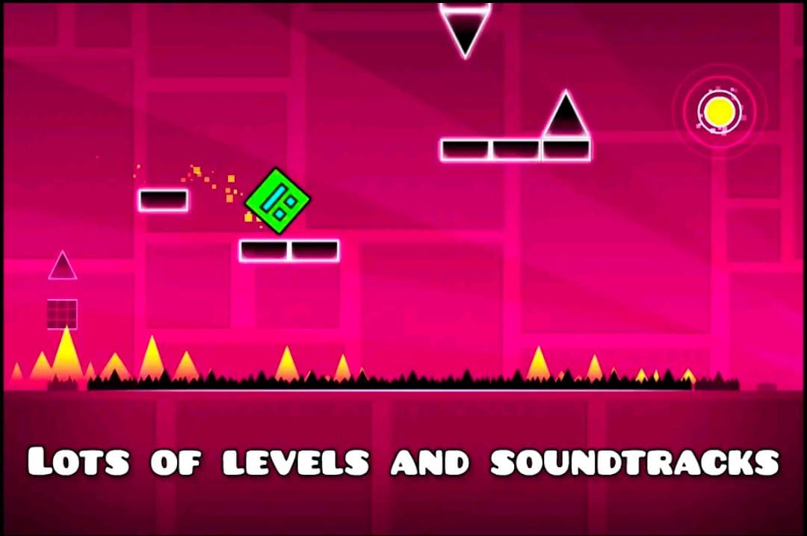

Geometry Dash has captivated millions of players worldwide with its dynamic and challenging gameplay. If you’ve been an avid fan or a curious new player, you know that Geometry Dash takes skill, patience, and plenty of retries to master. For those looking to experience the full spectrum of excitement, downloading the **Geometry Dash 2.206 APK** with everything unlocked is a game-changer. In this article, we’ll guide you through how to access and enjoy the ultimate version of Geometry Dash, equipped with all the levels, features, and customizations fully unlocked.

**What is Geometry Dash 2.206?**

Geometry Dash 2.206 is an updated version of the [geometry dash 2.206 apk all unlocked](https://geometerydashh.com/geometry-dash-lite/) classic Geometry Dash game, renowned for its unique combination of rhythm-based platforming and intense, fast-paced gameplay. Developed by RobTop Games, Geometry Dash challenges players with an array of levels, each filled with tricky obstacles, precise jumps, and adrenaline-pumping music that keeps the players on their toes. This version, **2.206**, comes with several enhancements and bug fixes, ensuring smoother gameplay and better overall performance.

**Why Download the Geometry Dash 2.206 APK with Everything Unlocked?**

Downloading the **Geometry Dash 2.206 APK with everything unlocked** allows you to bypass the usual grind of unlocking levels, icons, and other game elements. In this modified version, players gain access to all:

* Levels, including secret and user-created levels
* Icons and customization options
* Power-ups and abilities
* Soundtracks and effects

By using the unlocked APK, you’re free to explore every facet of Geometry Dash without limits, making it ideal for players who want to experience the game in its entirety without waiting or grinding through levels.

**Key Features of Geometry Dash 2.206 APK Unlocked**

Below are the key features that make the **Geometry Dash 2.206 APK with everything unlocked** the ultimate experience:

**1. Full Access to All Levels**

One of the main attractions of the unlocked APK version is having full access to every Geometry Dash level, including fan-favorite levels and challenging community-made content. Whether it’s the thrilling official levels crafted by the developers or the intricate custom levels by users, every stage is available right from the start.

**2. Complete Icon and Character Customization**

In Geometry Dash, icons and character customization are a big part of personalizing the gaming experience. With the 2.206 unlocked APK, you gain access to an expansive library of icons, skins, and colors, allowing you to modify your character to suit your unique style. Stand out from the crowd with rare skins and color options that typically require hours of gameplay to unlock.

**3. Enhanced Graphics and Smooth Gameplay**

Geometry Dash 2.206 APK offers refined graphics and a smoother gameplay experience. Players will notice improved graphics and optimized performance, resulting in a seamless gaming experience, even in high-speed, complex levels. These enhancements are especially beneficial for those using higher-end devices, as they can maximize the potential of the game’s visuals and animations.

**4. Unlocked Power-Ups and Abilities**

In this version, every power-up and special ability is unlocked from the beginning. Master unique powers like flying, double-jumping, and wall-jumping without waiting. This makes completing tougher levels more enjoyable as players can employ different strategies and abilities right away.

**5. Access to Every Soundtrack**

Music is a core element of Geometry Dash. With the 2.206 APK, you gain unrestricted access to every in-game soundtrack, including iconic tunes and user-uploaded tracks. This version gives you the full selection, which enhances the immersive rhythm-based gameplay that Geometry Dash is celebrated for.

**How to Download and Install Geometry Dash 2.206 APK with Everything Unlocked**

If you’re ready to dive into Geometry Dash with all its features unlocked, follow these steps to download and install the 2.206 APK:

**Step 1: Enable Unknown Sources on Your Device**

To install the APK file, go to your device’s **Settings** > **Security** > **Unknown Sources**. Toggle the option to allow your device to install applications from sources outside the Google Play Store.

**Step 2: Download the Geometry Dash 2.206 APK File**

You’ll need a reliable source to download the APK file. Make sure to download from a trustworthy site to avoid viruses or malware. Look for a verified link that provides the latest version, **Geometry Dash 2.206 with everything unlocked**.

**Step 3: Install the APK**

After downloading the APK file, locate it in your device’s downloads folder. Click on the file to start the installation process. Follow the on-screen prompts, and once installed, you’re ready to play!

**Step 4: Launch and Enjoy the Game**

Open Geometry Dash 2.206 APK and start enjoying the fully unlocked experience. With everything available at your fingertips, you can explore all levels, characters, and soundtracks without limitations.

**Pro Tips for Mastering Geometry Dash 2.206 with Everything Unlocked**

Even with everything unlocked, Geometry Dash can be challenging. Here are some expert tips to help you become a top player:

**1. Start with Easier Levels**

Before diving into the high-difficulty levels, start with easier levels to get comfortable with the controls and gameplay. Levels like *Stereo Madness* and *Back on Track* are ideal for warming up and honing your reflexes.

**2. Take Advantage of Practice Mode**

The **Practice Mode** is invaluable, especially for tackling difficult levels. This mode allows you to set checkpoints, so you can practice tricky parts without starting over. Use Practice Mode strategically to improve your skills and learn the layout of each level.

**3. Sync Your Movements with the Beat**

Geometry Dash is heavily influenced by rhythm, so try to move in sync with the beat of the soundtrack. The rhythm often cues upcoming obstacles and jumps, helping you anticipate moves. Paying close attention to the beat can be a game-changer.

**4. Customize Your Icon for Better Visibility**

With every customization unlocked, choose icons and colors that stand out against the level backgrounds. This makes it easier to keep track of your character, especially in levels with high-speed sections and visually busy environments.

**5. Explore User-Created Levels**

Geometry Dash 2.206 allows access to the user-created levels library, where you can find unique and challenging stages crafted by the community. Playing these levels can offer a fresh experience and expose you to various gameplay styles.

**Is Downloading Geometry Dash 2.206 APK with Everything Unlocked Safe?**

While using an unlocked APK can be tempting, it’s essential to be cautious. Here’s a quick guide on staying safe when downloading APK files:

1. **Only Download from Reputable Sources:** Look for APKs from verified sources to reduce the risk of malware.
2. **Use Antivirus Software:** Having antivirus software on your device can help protect against potential threats.
3. **Check Permissions:** Ensure the APK doesn’t request unnecessary permissions.

**Frequently Asked Questions (FAQ)**

**Is the Geometry Dash 2.206 APK Free to Download?**

Yes, many sites offer the APK for free. However, always verify the source to avoid downloading potentially harmful files.

**Can I Play Geometry Dash 2.206 Offline?**

Yes, once installed, Geometry Dash can be played offline. This makes it ideal for gaming on the go, as you won’t need an internet connection to enjoy the unlocked levels and features.

**Will I Still Receive Updates?**

Typically, APK versions do not update automatically. You’ll need to download newer APKs as updates are released.

**Does Unlocking Geometry Dash Affect My Gameplay Progress?**

No, using an unlocked version should not erase your progress. However, it’s recommended to back up your data if you’re upgrading from a previous version.

**Is the APK Compatible with All Devices?**

Geometry Dash 2.206 APK should be compatible with most modern Android devices. However, performance may vary depending on your device’s specifications.

**Final Thoughts on Geometry Dash 2.206 APK with Everything Unlocked**

For fans of Geometry Dash, the **2.206 APK with everything unlocked** provides the ultimate experience. From unlimited levels to custom soundtracks and full character customization, this version allows players to experience everything Geometry Dash has to offer. By following the steps and tips outlined above, you’ll be well-equipped to maximize your enjoyment and dominate the game’s toughest challenges.

**Download the Geometry Dash 2.206 APK today** and immerse yourself in an unparalleled rhythm-based adventure that tests your reflexes, timing, and creativity. Enjoy the full scope of Geometry Dash, and discover why this game continues to be a fan favorite.